Chapter 8: Stock Valuation

Concept Questions

- Dividend Growth Model: Under what two assumptions can we use the dividend growth model presented in the chapter to determine the value of a share of stock? Comment on the reasonableness of these assumptions.

The general method for valuing a share of stock is to find the present value of all expected future dividends. The dividend growth model presented in the text is only valid under the following two assumptions:

- If dividends are expected to occur forever, i.e., the stock provides dividends in perpetuity;
- If a constant growth rate of dividends occurs forever.

A violation of the first assumption might be a company that is expected to cease operations and dissolve itself some finite period of years from now. The stock of such a company would be valued by applying the general method of valuation explained in this chapter. That is, we would determine the present value of the finite expected dividends rather than an infinite dividend stream. A violation of the second assumption might be a start-up firm or a high-growth firm that isn’t currently paying any dividends, but is expected to eventually start making dividend payments some period of years from now. This stock would also be valued by the general dividend valuation method explained in the text.

An interesting side question is if a share of stock has value if it is never expected to pay a dividend. The answer depends on the issue of control. If you, as the owner of this share of stock, control the decision concerning future dividend payments, then the share of stock has value because you can elect to have the firm pay a dividend. If, on the other hand, you do not control this decision (i.e., your share represents a minority interest), then if a dividend is never paid, and no other cash flows are likely to accrue to your share (e.g., the ability to sell your share of stock), then the share of stock has no value!

6. Dividend Growth Model: Based on the dividend growth model, what are the two components of the total return on a share of stock? Which do you think is typically larger?

The two components are the dividend yield and the capital gains yield. For most companies, the capital gains yield is larger. This is easy to see for companies that pay no dividends. For companies that do pay dividends, the dividend yields are rarely over 5% and are often much less.

7. Growth Rate: In the context of the dividend growth model, is it true that the growth rate in dividends and the growth rate in the stock price are identical?

Yes. If the dividend grows at a steady rate, so does the stock price. In other words, the stock’s dividends grow at the same rate at which the stock’s capital appreciation grows by.

11. Stock Valuation: Evaluate the following statement: Managers should not focus on the current stock value because doing so will lead to an overemphasis on short-term profits at the expense of long-term profits.

First, the managers’ focus should be on cash flow, not accounting profits! This part of the statement makes the entire statement false. However, if we assume managers focus on cash flows rather than profits, what about the rest of the statement?

Second, presumably the current stock value reflects the risk, timing, and magnitude of all future cash flows (both short-term and long-term). If this is correct, then the statement is false.

A final note concerns managers’ short- versus long-term focus. As previously stated at the beginning of the course, management’s focus should be to maximize the value of the firm. Unfortunately, many management teams are faced with a trade-off between meeting analysts’ quarterly expectations (short-term focus) and long-term value creating. Even more unfortunate, many focus primarily on meeting current analysts’ short-term quarterly earnings. Often these poor managers will forego value creating investments (e.g., fixed assets, R&D expenditures, etc.)in order to meet analysts’ expected quarterly forecasted earnings.

12. Two-Stage Dividend Growth Model: One of the assumptions of the two-stage growth model is that the dividends drop immediately from the high growth rate to the perpetual growth rate. What do you think about this assumption? What happens if this assumption is violated?

If this assumption is violated, the two-stage dividend growth model is not valid. In other words, the price calculated will not be correct. Depending on the stock, it may be more reasonable to assume that the dividends fall from the high growth rate to the low perpetual growth rate over a period of years rather than in one year.

Problems

- Stock Values: The Jackson-Timberlake Wardrobe (JTW) Co. just paid a dividend of $1.95 per share on its stock. The dividends are expected to grow at a constant rate of 6 percent per year indefinitely. If investors require a 11 percent return on JTW stock, what is the current price? What will the price be in three years? In 15 years?

We can answer these questions using the constant dividend growth model:

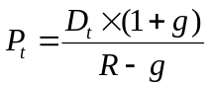

The price of JTW stock today is:

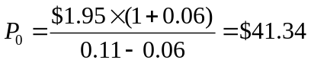

The price of JTW stock three years from now would be:

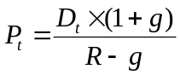 so 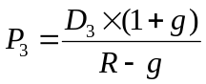 or 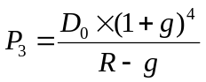

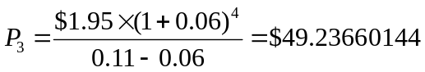

We can accomplish the same for year 15:

so 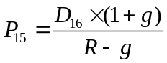 or 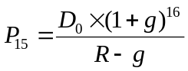

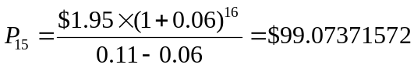

We can also calculate the stock prices using the following equation:

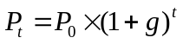

2. Stock Values: The next dividend payment by Top Knot, Inc., will be $2.10 per share. The dividends are anticipated to maintain a 5 percent growth rate forever. If the stock currently sells for $48.00 per share, what is the required return?

We need to algebraically solve the constant growth model equation for R, the required return:

and solving for R 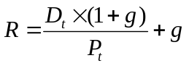

Using this equation:

And since we are given the next dividend, D₁:

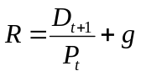

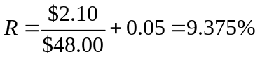

3. Stock Values: For the company in the previous problem, what is the dividend yield? What is the expected capital gains yield?

The dividend yield is next year’s dividend divided by the current stock price:

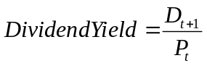

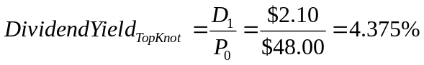

The capital gains yield is the same of the constant dividend growth rate of 5%

- Stock Values: Apocalyptica Corp. pays a constant $9.75 dividend on its stock. The company will maintain this dividend for the next 11 years and will then cease paying dividends forever. If the required return on this stock is 10 percent, what is the current share price?

The price of any financial instrument is the PV of the future cash flows. The future dividends are an 11 year annuity of $9.75, so the PVA of Apocalyptica is:

8. Valuing Preferred Stock: Resnor, Inc., has an issue of preferred stock outstanding that pays a $5.50 dividend every year in perpetuity. If this issue currently sells for $108 per share, what is the required return?

The price of a share of perpetual preferred stock is the dividend divided by the required return. This is the equation for a perpetuity. This is also the same equation as the constant growth model with g, the growth rate in dividends, equal to zero. Since most preferred stock pays a fixed dividend, the growth rate in dividends is zero. Therefore, the required rate of return is:

with g = 0 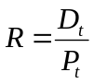

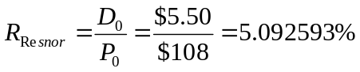

11. Nonconstant Growth: Metallica Bearings, Inc., is a young start-up company. No dividends will be paid on the stock over the next nine years because the firm needs to plow back its earnings to fuel growth. The company will pay a $10 per share dividend in 10 years and will increase the dividend by 5 percent per year thereafter. If the required return on this stock is 14 percent, what is the current share price?

The firm pays no dividend for 10 years. Once the company begins paying dividends, it will have a constant growth rate of 5%. Therefore, we can use the constant growth model equation:

This means that we will use the dividend in year 10 to find the value of the stock in year 9, and then discount year 9’s stock price back to today. The stock’s price in year 9 is:

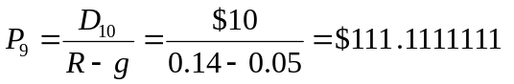

Discounting this value back 9 years at the required return give a PV of:

14. Supernormal Growth: Marcel Co. is growing quickly. Dividends are expected to grow at a 30 percent rate for the next three years, with the growth rate falling off to a constant 6 percent thereafter. If the required return is 13 percent and the company just paid a $1.80 dividend, what is the current share price?

With supernormal dividends, we need to first determine the dividends prior to the constant growth period. Since D₀ = $1.80, we can determine the dividends during the supernormal growth period:

Notice that since the supernormal growth rate is constant at 30%, we could have determined the dividends during the supernormal growth period as follows:

Next, we need to find the value of the stock after the supernormal growth period (i.e., the stock’s value based on constant growth):

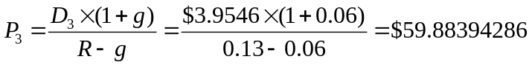

We now have the cash flows necessary to determine the value of the stock today. We must discount these cash flows back to today as follows:

Summing these PVs together gives us the stock price today:

We could have also used the stack registers on our financial calculators to do this more quickly. Note that D₃ and P₃ occur at the same point in time, so they will have to be added together:

We could also use the two-stage dividend growth model for this problem since the first growth rate, g₁,is a constant 30% and the second growth rate, g₂,is a constant 6%. Therefore, we can use the two-stage growth model equation, which is:

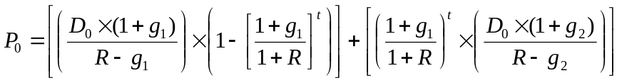

16. Negative Growth: Antiques R Us is a mature manufacturing firm. The company just paid a $10.46 Dividend, but management expects to reduce the payout by 4 percent per year indefinitely. If you require an 11.5 percent return on this stock, what will you pay for a share today?

The constant growth model can be applied even if the dividends are declining by a constant percentage. We need to make sure we input the growth rate as a negative. Therefore, the current price is:

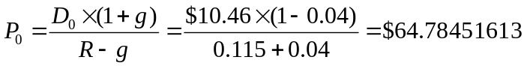

19. Using Stock Quotes: You have found the following stock quote for RJW Enterprises, Inc., in the financial pages of today’s newspaper. What was the closing price for this stock that appeared in yesterday’s paper. If the company currently has 25 million shares of stock outstanding, what was the net income for the most recent four quarters?

52-Week Yld Vol Net
Hi Lo Stock (Div) % PE 100s Close Chg
72.18 53.17 RJW (1.48) 2.1 19 17652 ?? -0.23

The annual dividend paid to stockholders was $1.48 and the dividend yield is 2.1%. Using the equation for dividend yield, we can find RJW’s current stock price:

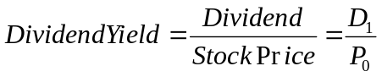

Technically, we require the next year’s dividends, but let’s assume the dividend is constant:

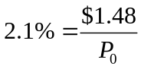

Therefore, the current price is:

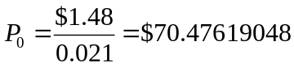

The Net Chg of the stock shows the stock decreased by $0.23 on this day, so the closing stock price yesterday was:

To find the net income, we need to find the EPS. The stock quote tells us eth PE ratio for this stock is 19. Since we know the stock price as well, we can use the PE ratio to solve for the EPS as follows:

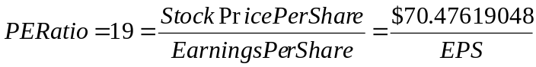

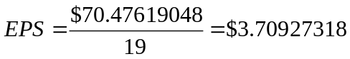

We know that EPS is just the total net income divided by the number of shares outstanding, so:

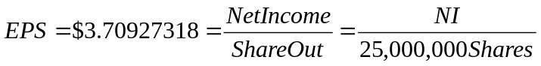

- Two-Stage Dividend Growth Model: Thirsty Cactus Corp. just paid a dividend of $1.25 per share. The dividends are expected to grow at 28 percent for the next eight years and then level of to a 6 percent growth rate indefinitely. If the required return is 13 percent, what is the price of the stock today?

We can use the two-stage dividend growth model for this problem, which is:

